**LAPORAN PRAKTIKUM PENGOLAHAN CITRA DIGITAL**

**22. FEATURE EXTRACTION AND REPRESENTATION**



**Disusun oleh :**

**Nama :**

**NPM :**

**Kelas : IF4..**

**PROGRAM STUDI INFORMATIKA**

**FAKULTAS ILMU KOMPUTER DAN REKAYASA**

**UNIVERSITAS MULTI DATA PALEMBANG**

**2024**

**TUTORIAL : FEATURE EXTRACTION AND REPRESENTATION**

**Goal**

The goal of this tutorial is to learn how to use MATLAB to extract features from binary images and use these features to recognize objects within the image.

**Objectives**

* Learn how to use the regionprops function to extract features from binary objects.
* Learn how to perform feature selection and use the selected features to implement a simple, application-specific, heuristic classifier.

**What You Will Need**

* Test images TPTest1.png, shapes23.png, and Test3.png.

**Procedure**

We will start by exploring the rgb2hsv function.

1. Load test image TPTest1.png (Figure 22.1(a)) and display its contents.



**FIGURE 22.1** Test images for this tutorial: (a) steps 1–6; (b) step 7; (c) step 11.



1. Use bwboundaries to display the boundaries of the objects in the test image.

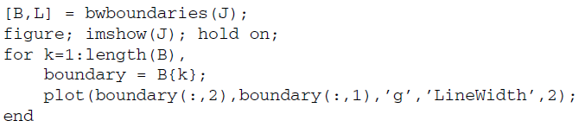

1. Use bwlabel to label the connected regions (i.e., objects) in the test image, pseudocolor them, and display each of them with an associated numerical label.

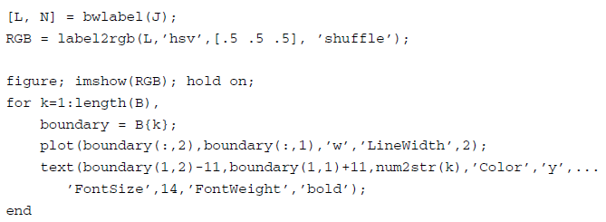

|  |
| --- |
|  |
|  |

**Question 1** What is the value of N returned by bwlabel? Does it make sense to you?

|  |
| --- |
| Masuk akal karena gambar TPTest1.png memang menampilkan contoh misalnya 4 objek yang berbeda misalnya 2 kotak dan 2 lingkaran. Tapi agar hasilnya benar, pastikan gambar diubah ke biner terlebih dahulu sebelum diberi label. |

1. Use regionprops to extract the following binary features for each object in the image (top left square, top right square, small circle, big circle): area, centroid, orientation, Euler number, eccentricity, aspect ratio, perimeter, and thinness ratio.
2. Organize the feature values and object names in a table (see Table 22.1), for easier comparative analysis.

TABLE 22.1 Table for Feature Extraction Results

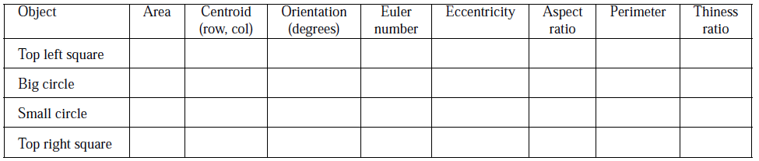

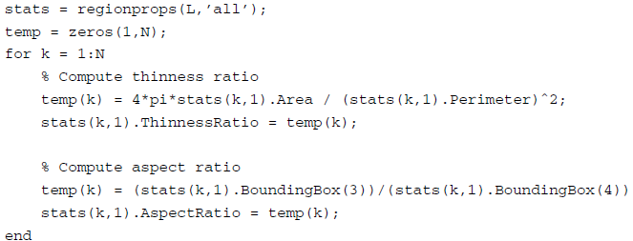

|  |
| --- |
|  |

**Question 2** Do the results obtained for the extracted features correspond to your expectations? Explain.

|  |
| --- |
| Ya Jika nilai-nilai ini muncul dari hasil analisis maka bisa dikatakan hasilnya sesuai dengan yang diharapkan.   * Thinness Ratio mengukur seberapa bulat suatu objek yang nilai mendekati 1 menunjukkan bentuk yang mendekati lingkaran sempurna. * Aspect Ratio membandingkan lebar dan tinggi dari bounding box yang dimana nilai mendekati 1 berarti bentuknya proporsional baik kotak maupun lingkaran. |

**Question 3** Which of the extracted features have the best discriminative power to help tell squares from circles? Explain.

|  |
| --- |
| Thinness Ratio adalah fitur yang paling bagus untuk membedakan antara lingkaran dan persegi. Karena lingkaran adalah bentuk dengan efisiensi maksimum luas terbesar untuk keliling tertentu sehingga nilai Thinness Ratio-nya mendekati 1. |

**Question 4** Which of the extracted features have the worst discriminative power to help tell squares from circles? Explain.

|  |
| --- |
| Aspect Ratio adalah fitur yang paling kurang efektif untuk membedakan persegi dan lingkaran. Karena lingkaran maupun persegi idealnya memiliki panjang dan lebar yang hampir sama, sehingga nilai Aspect Ratio-nya mendekati 1 pada keduanya. |

**Question 5** Which of the extracted features are ST invariant, that is, robust to changes in size and translation? Explain.

|  |
| --- |
| Fitur yang ST invariant thinness Ratio dan aspect Ratio. Translasi tidak memengaruhi kedua fitur tersebut karena posisi objek tidak mengubah perbandingan bentuknya. Aspect Ratio hanya membandingkan lebar dan tinggi, yang juga berubh secara proporsional terhadap skala. |

**Question 6** If you had to use only one feature to distinguish squares from circles, in a ST-invariant way, which feature would you use? Why?

|  |
| --- |
| Thinness Ratio adalah fitur yang paling sensitif terhadap bentuk, terutama kelengkungan. Walaupun persegi dan lingkaran memiliki Aspect Ratio yang hampir sama thinness Ratio dapat dengan jelas membedakan lingkaran dari bentuk lain karena hanya lingkaran sempurna yang memiliki nilai mendekati 1. |

1. Plot the 2D feature vectors obtained using the area and thinness ratio of each object.

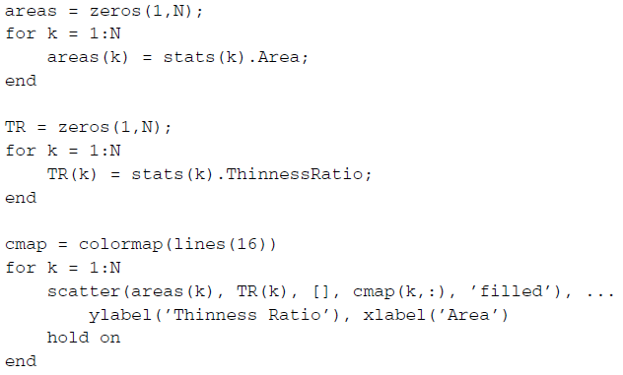

|  |
| --- |
|  |
|  |

1. Repeat steps 1–6 for a different test image, Test3.png (Figure 22.1b).
2. Write MATLAB code to implement a heuristic three-class classifier capable of discriminating squares from circles from unknown shapes. Hints: Use a subset of features with enough discriminative power and encode your solution using if-else-if statements. Use the code snippet below to get started.

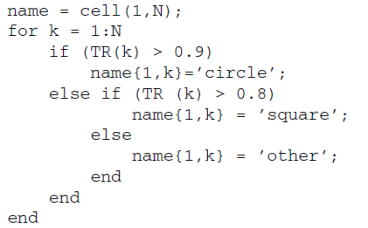

1. Test your solution using the TPTest1.png and Test3.png test images.
2. Test your solution using different test images.
3. Extend your classifier to be able to process color images, for example, shapes23.png (Figure 22.1).

|  |
| --- |
|  |